Kirsten Adkins | kirsten.adkins@glasgow.ac.uk | https://www.kirstenadkins.co.uk
Media and Conflict Memory: an interdisciplinary workshop

Horseshoe Cartographies
Conflict memory and the mapping of military belonging in 21st Century Reportage
This submission is concerned with the framing and mediation of 21st century military action during the period of allied invasions in Iraq and Afghanistan. It enlists an interdisciplinary methodology in textual analysis and visual practice, to examine concepts of belonging and exile in British promotional and news media. A bricolage practice involving the cutting and repositioning of paper and felt becomes an investigative tool through which I examine the arrangement of bodies in scenes of military violence. The mapping of war is thus articulated as a horseshoe cartography, a visual palimpsest that describes the co-dependency between safety and threat as it is spatially organised within the mise-en-scene. Through visual practice I further develop and extend my contention that the construction and mediation of war is based on a cultural memory that is established, embedded, repeated and naturalised over time. Juxtapositions between interior and exterior shapes and spaces provide cartographies of military fraternal belonging and hostile otherness. The horseshoe connotes a bringing together of contradictory themes of openness and closure and with this a porosity between concepts of selfhood, military solidarity,violence and threat. This is underpinned by Michael Shapiro’s theorisations on cartographic violence and refers to the Foucauldian concept of geopolitical power dynamics between states and state subjects. A cultural patrimony based on models of identity difference has origins in popular culture including Hollywood cinema, which provided a template for cartographies of security and enmity in the landscapes of frontier America. Conflict memory is conceptualised as a fragile dialectic where the visual construction of belonging will always be reliant on the prospect of exile. How the world is perceived becomes dependent on the shape that is imposed on it.
This submission comprises a presentation which includes explorations in film and approaches in text and collage.
I would be able to attend the workshop in person.

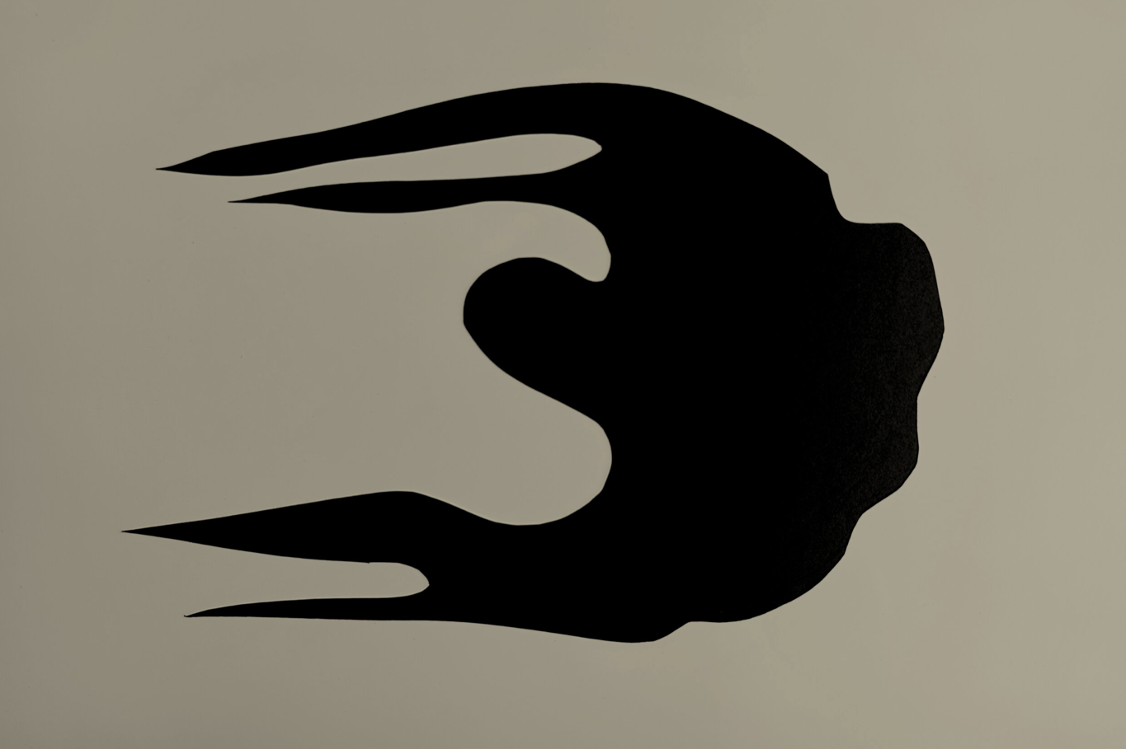
a group of soldiers take shelter under a tarpaulin in a jungle monsoon, where they drink tea, clean their weapons and stare at something outside the frame

Kirsten Adkins: Horseshoe Cartography 3 (papercut and industrial felt)
Biography
Kirsten Adkins is an artist and filmmaker whose practice combines experimental filmmaking with photography, drawing and creative writing. She has a professional background in documentary television having previously worked at the BBC as a director and producer. This work informs her research practice where she combines interdisciplinary methods in visual arts, film and writing to provoke new conversations around concepts of home, place and belonging in times of war. She has published, broadcasted and exhibited nationally and internationally. She currently teaches filmmaking and experimental film practice at the University of Glasgow. https://www.kirstenadkins.co.uk

Michael Shapiro, The New Violent Cartography, in Security Dialogue 38(3) (Sage Publishing, 291-313: 2007).

