Bearing Witness in Palestine
Within one of the longest running conflicts in the world today, Palestinians and their advocates have embraced citizen journalism as a form of resistance against Israeli occupation.
While citizen journalism is not a new concept, the rise of the internet and smartphones has led to an increase in ordinary citizens recording and sharing what they are witnessing. Perhaps the most well known example of this phenomenon is the Black Lives Matter movement in the United States, where bystanders use social media to upload photographic evidence of police brutality to challenge police power and make misconduct visible to those who might otherwise not be aware of it. That citizens can, and in fact, do, record police encounters may represent an important accountability check on state authority. In this way, citizens are able to take on the watchdog role by bearing witness and relaying information to those who were not present, as the mainstream media traditionally would have done. Alissa Richardson writes at length about this in her recent book “Bearing Witness while Black” which explores the potential for citizen journalists to change the narrative around police brutality and race in the United States. This type of witnessing involves archiving evidence of police brutality for future generations as part of a way of connecting to injustices.
In a similar way, Palestinians and international observers document police and military actions within the Israel/Palestine conflict which has been the subject of much international media coverage over the past few decades. In fact, both Israel and Palestine recognise that the struggle to manage the media narrative can be as important as the struggle on the ground, with Israel using the media to legitimise military actions while Palestine views it as a way to level the playing field and gain international support and solidarity. In a key study by the Glasgow Media Group, the UK mainstream media often presents unbalanced reporting on the conflict, favouring Israeli perspectives over Palestinian ones. However, conflicts are increasingly being played out within a hybrid media system where information can be shared through social media instead of, or as well as, the mainstream media.
My research is an in-depth exploration of the way that Palestinian advocacy groups share images on social media platforms and the responses received. Over a period of six months, I gathered posts from Instagram, Twitter and Facebook from eighteen different Palestinian advocacy groups including Friends of Al-Aqsa, International Solidarity Movement and Stop The Wall. I then filtered the posts to analyse those showing interactions between Palestinians and Israeli security forces.
Evidence of citizen witnessing was found across all three platforms, with many images showing Israeli soldiers in full military uniform detaining, often violently, Palestinian civilians or responding with violence to Palestinian protests. The images were sometimes accompanied by details of the incident shown in the image in the caption or used as a standalone image without any context as part of an unrelated post. Alongside the images of violence by Israeli forces were images of bulldozers tearing down Palestinian buildings, and images of Palestinians queuing at checkpoints. As most of the images were not attributed to a specific source, there appears to be a blurring of the boundary between the press and the citizen journalist as most images were not obviously taken from a mobile phone versus a professional camera. Some of the images show evidence that both journalists (in distinctive ‘press’ vests with cameras on tripods) and ordinary Palestinians (with mobile phones) are actively recording scenes on the ground.
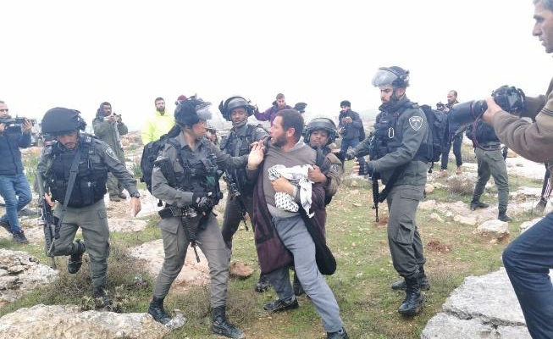
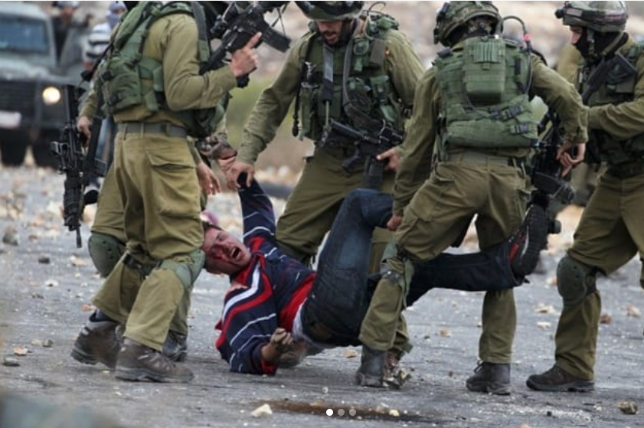
Figure
https://twitter.com/ISMPalestine/status/1230190554098601985/photo/1
Figure 2
https://www.instagram.com/p/Bv63420hAKT/

While there were images and video clips showing violence by Israeli forces, whether that was physical violence or property destruction, many of the images were more mundane, for example, showing soldiers in full uniform with machine guns walking through residential streets, school children walking behind them. It was these scenes of everyday life for Palestinians living under occupation that were the most unsettling, perhaps contributing to the anti-normalisation of Israel which is a key strategy of Palestinian advocacy campaigns. With the recent normalisation of relations between Israel and UAE and, now, Bahrain (https://www.aljazeera.com/news/2020/09/facing-normalisation-threat-palestinians-respond-unity-200914175752492.html), it is likely that these types of images will continue to be an important reminder to the rest of the world that the reality of Palestinian life is far from normal.
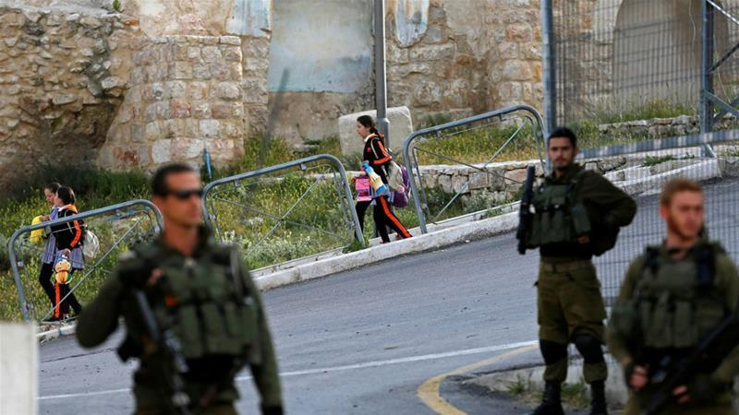
Figure 3 https://twitter.com/prclondon/status/1258411751659487232/photo/1
Another key theme running through the posts across different accounts and platforms is solidarity. Interestingly, this goes both ways, with advocacy groups framing their captions along the lines of building international solidarity, but also showing solidarity with other causes, most noticeably Black Lives Matter. Images were posted showing Israeli soldiers kneeling on the necks of Palestinians next to images of George Floyd’s death. The parallels between Palestinians and African Americans such as the historic displacement, systematic discrimination and state violence are hard to ignore. It is these connections between marginalised groups worldwide that can emerge and be strengthened through the internet which removes traditional barriers and borders to transnational advocacy.
While much research has been carried out on citizen journalism in the US context, very little is known about witnessing in non-USA contexts particularly in places where it is the military, rather than police, who are the face of law enforcement. My research contributes to the emerging body of work on citizen witnessing in a global context. Citizen witnessing is likely to increase as more places around the world gain access to tools such as mobile phones and social media which make it easy to record and share experiences. It is also likely that we will see more of these transnational advocacy networks characteristic of the Palestinian cause. It is therefore important to understand the power of citizen witnessing and how, by making those in positions of power visible, thereby reducing their ability to act without consequence, we can build more transparent and accountable societies, whether that may be in the United States or in Palestine.

